*Knowing Christ*

*and making Him known*

*by being a voice of hope*

*in our church,*

*community, and world.*

**2024 Annual Report**

**Presented: February 2, 2025**

**Corner House Christian Church**

**6954 Chestnut Ridge Road**

**Hubbard, Ohio 44425**

Phone: 330-534-4665

Dave: 330-531-1897

Email: churchoffice@cornerhousecc.org

Dave: davecoxson@cornerhousecc.org

*www.cornerhousecc.org*

**Table of Contents**

**Minister’s Report**

**Elders Report**

**Deacon’s Report Updated**

**Trustees Report Updated**

**Church Clerks Membership Report Updated**

**Ministries**

**Adult Education Report**

**Children’s Education Report Updated**

**Fellowship Ministry Report**

**Missions Ministry Report**

**Missions Financial Report**

**Women’s Fellowship Ministry Report**

**Worship Ministry Report Updated**

**Financials**

**Finance Team Report**

**Treasurer’s Chart of Yearly Revenue and Expenses**

**Treasurer’s Proposed Budget**

**MINISTER’S REPORT**

After Moses died and Joshua led the Israelites into the promised land, the Lord said to Joshua, This day I will begin to exalt you in the sight of all Israel, so they may know that I will be with you as I was with Moses. That day, the ark of the covenant was carried by the priests in front of all the people and into the Jordan River. As their feet entered the river, the waters stood still in a single heap. The ark of the Lord and more than 40,000 of the people of Israel crossed the Jordan River on dry ground not a foot was wet. The Lord then ordered Joshua to take twelve stones from the middle of the Jordan and set them up in Gilgal ‑ these twelve stones a reminder for generations to come of the works of the Lord. (Joshua 3:7‑4:25)

God tells the people, over and over in psalm and story, in dialogue and in prose, to remember.

Remember the works of the Lord. Remember the goodness of our God. Remember that God has been with us, that God is with us, that God will forever be with us.

God gives us ways to remember. The rainbow after the rain. The twelve stones of Gilgal. The people in our community who share their stories of God in their lives. The old cross hanging behind the baptismal and the new cross hanging in our foyer. The bread and cup given in remembrance of Christ. That baptism that gave you new birth and united you with brothers and sisters in Christ. Remember.

Richard Rohr states that our remembering will be the highway into our future, the straight path the Lord has promised through John the Baptizer. This remembering, even though a source of both pain and hope, gives us the energy and power to keep moving into Gods promise, the dream, the vision of what can be and whats beyond this moment, just on the other side of the river.

As we look back to look ahead, one of the great joys of 2024 was the increase in new attenders and the receiving of new members. We celebrated the following baptisms including Kevin Carpenter; Billy Siverling; Daniel Trickett, Suzi Brannan; Athena Brannan; Dallas Brannan; Paula Fields; Michelle Allen; Lee Ann Jacobs; Tommy Lee Jacobs; Blaize Grover; Adam Woolensack; Heather Josephs and Samantha Allen.

We welcome new members by transfer Greg and Sarah Benson; Sandy Perry; Tiffany Vestal (Luna); Jake and Kelsey Snyder (Mitch and Miles); Justin and Jessica Brown; Dennis and Cindy Vestal; Shirley Vestal and Mark Surma.

As a congregation, looking back there are some special people who are no longer with us.

We remembered Members Peggy Tobey, Russell Root, and Harry Cracraft. In addition, I conducted memorial services for Don Stewart (Memorial Service), Timothy Lytle, Mary Anne Orr, Vivian and Diana Kirsh, Jeff Thomas, Ernie Weaver, Marilyn Kilar, Leonard Osborn, and Russel Humphrey. Others had personal losses, for instance Christine King lost a father, Bill Kilar lost a brother Danny, and Irene Distasio also lost a son, Dominic. I share in your losses as my wife and our family made the trip to Indiana last March to take part in the memorial service of my wifes mom, Ruth Ann Custer.

During 2024 I preached 46 times, Taught or facilitated 120 classes, I was able to make over 130 hospital visits, 60 visits in our nursing homes and Rehab facilities, 150 home visits and 4 prison calls. I facilitated 15 counseling sessions, attended numerous church meetings including Elders, Vision, Evangelism, Childrens Discipleship, Worship and Praise Practices; 11 Mens Breakfasts, went on 3 Police Ride Alongs and on an emergency call, attended 5 HCIA Meetings including hosting 2; hosted one HCIA meeting and an HCIA annual holiday carry‑in. We hosted 5 Penn/Ohio preachers’ meetings while attending several others; attended 4 meetings at Elkhorn Christian Service Camp. I led in the planning and facilitation of our annual/community wide "National Day of Prayer Service." I had the opportunity to preach the message at our community Baccalaureate service this past May. I led 12 CARE meetings at the public library. I was also able to provide transportation to and from the area courthouses for a few who needed those services. We also provided and packed meals for our city police department in cooperation with the City Transformation Team. Corner House also has a weekly posting in the Review Newspaper that features my sermon notes and occasionally an inspiring article.

**LOOKING BACK ON 2024**

Looking behind and looking ahead to the future let us remember our Mission/Vision Statement

Knowing Christ and Making Him Known, by being a voice of hope in our church, community, and world.

**Theme: Remembering**

As we reflect on the past year, we are reminded of the many ways our church has embodied our mission. Through various events and acts of service, we have created memories that not only strengthen our faith but also deepen our connections with one another and our community.

**Key Events and Highlights**

Remembering Our Newest Blessings: Baby Appreciation Sunday. We celebrated the precious gift of new life with our Baby Appreciation Sunday, where we welcomed and blessed the newest members of our church family.

**Remembering Community and Support: Autism Awareness and Support Events**

We hosted two AATAP events for the autistic community:

Easter Egg Hunt: Families enjoyed a fun‑filled day, creating cherished memories.

Trunk or Treat: This event provided a safe and enjoyable Halloween experience for children and their families.

**Remembering Generosity: Church‑Wide Garage Sale**

Our huge church‑wide garage sale was a resounding success, bringing our community together and raising funds for various church initiatives.

**Remembering Fellowship: Car Cruises**

We hosted two spectacular car cruises, attracting car enthusiasts from far and wide and fostering fellowship among participants.

**Remembering Connection: Dinner for Young Adults**

A special dinner for young adults provided a wonderful opportunity for connection, discussion, and spiritual growth.

**Remembering Joy: Trip to Waldameer Amusement Park**

Our trip to Waldameer Amusement Park was a fantastic outing that allowed families to bond and enjoy a day of fun and relaxation.

**Remembering the Children of the World**

We hosted a Lifeline Food Packing Event that once again proved to be a labor of love worth investing our time to make happen.

**Remembering Creativity: Sip and Paint Events**

We hosted a couple of sip and paint events, combining creativity with fellowship. These events were a hit, encouraging artistic expression and building relationships.

**Remembering Support: Standing in the Gap Service**

Our annual Back to School Standing in the Gap service was a powerful time of prayer and support for students, teachers, and families as they prepared for the new school year.

**Remembering Generosity: Pancake Breakfast Fundraiser**

The pancake breakfast fundraiser for Elkhorn Valley Christian Service Camp was not only delicious but also raised essential funds to support the camps mission.

**Remembering Togetherness: Movie Night**

We enjoyed a delightful movie night, bringing families and friends together for an evening of entertainment and community.

**Remembering Inspiration: Park Avenue Brass Concert**

Hosting Park Avenue Brass was a musical highlight of the year, as their performance uplifted and inspired all who attended.

**Remembering Community: Church‑Wide Dinners**

We held two church‑wide dinners after Sunday services, fostering a sense of community and allowing us to share meals and fellowship.

**Remembering the Inter-generational Dinner**

Thanks to our children and their youth sponsors who gave our seniors a night of fellowship, enjoyment and great food.

**Remembering Compassion: Compassionate Friends Candlelight Vigil**

Hosting the Compassionate Friends candlelight vigil was a touching event that provided comfort and solidarity for those grieving the loss of a child.

**Remembering the Nativity: Children's Christmas Pageant**

Our annual Children's Christmas Pageant was a charming portrayal of the nativity story, filled with joy and the true spirit of Christmas.

**Remembering Our Savior: Christmas Eve Worship**

We concluded the year with our annual Christmas Eve Worship, a beautiful and reverent celebration of Christ's birth.

Corner House, we continue to play an active role among fellow Christians in our community.

Once again our food pantry ministry hosted 12 food giveaways.

**Conclusion**

As we look back on the past year, we are filled with gratitude for the moments we have shared and the ways we have lived out our mission. Remembering these events inspires us to continue knowing Christ and making Him known, being a voice of hope in our church, community, and world. We eagerly anticipate the coming year, ready to create new memories and embrace the blessings and challenges that lie ahead.

Thank you for being a part of our church family and for your continued support and participation in our mission. Lets continue to shine Christ's light in all we do.

In His service,

David Coxson

**ELDERS’ REPORT**

As we reflect on the year 2024, we are reminded of the blessings, challenges, and growth within our church community. We, the elders, Chuck Thompson, Steve Shrader, Dave Coxson and Jerry Coxson, meet bi-monthly on Mondays. We always welcome members of the congregation to share their concerns or present ideas. Our primary role is to provide spiritual direction and guidance to the congregation.

**Leadership and Transitions**

2024 has been a challenging year as one of our esteemed leaders, Herb Good, faced health issues that necessitated his move to North Carolina to be with family. In recognition of his nearly 40 years of services as a Deacon and Elder, we bestowed upon Herb the title of Elder Emeritus.

**Church Ministries and Activities**

We continue to actively serve and facilitate various church ministries, which include Vision, Discipleship, Worship, and Fellowship. Encouraging spiritual growth and community building. Finances and Buildings and Grounds: [Trustees] ensuring the financial health and maintenance of our church facilities.

We as elders also actively participate in and encourage ministry group leaders to meet quarterly for Ministry Group organizational meetings. Additionally, we are involved in teaching small groups and bible classes and overseeing the Deacon ministry, including benevolence.

**Deacon Training and Ordination**

Through nominations from the church membership and personal review, we will devote six meetings in 2025 to training and mentoring several men who were nominated to serve as deacons with the goal of ordaining them by 2026. At this time, we are also meeting with Fritz Houy to be ordained as an elder.

**Communion and Worship**

We have reinstated communion servers to distribute the Lords Supper and pass collection plates on every 5th Sunday, as well as assist with preparations for these events.

**Vision and Mission**

We continue to encourage a vision based on our mission statement and strive to uphold our values and goals.

**Treasurer Transition**

2024 was a year of transition between church treasurers. Our new church treasurer, Carm Shockey, and financial secretary, Patty Cabuno, have worked tirelessly. They have met with the elders each month to keep us informed about the financial aspects of the church and address any issues. Communication between the finance committee and the elders remains a key aspect we strive to maintain.

**Outreach and Evangelism**

In 2024 we approved the reestablishment of the Outreach/Evangelism ministry. We monitor weekly attendance and make efforts to greet and encourage newcomers as they integrate into the church fellowship.

**Community Engagement**

The elders are active in various church activities including Car Cruises and AATAP functions engaging with the community and fostering fellowship.

**Worship Ministry**

Actively participate in Sunday worship and Wednesday night Refuel.

**Conclusion**

We are grateful for the dedication and support of our church members, staff, and volunteers. Despite the challenges of the year, we have seen growth and continue to serve our community. We trust in God's guidance and look forward to the opportunities and blessings that 2025 will bring.

Acts 14:23 Paul and Barnabas appointed elders for them in each church and, with prayer and fasting, committed them to the Lord, in whom they had put their trust.

Submitted by Jerry Coxson

**DEACON’S REPORT**

At the beginning of March 2023, we split the benevolent fund and the food pantry funds. Some people were marking the benevolent and some were marking for food pantry. We put all the money in the benevolent fund at that time, due to the fact we received a grant from United HealthCare for $1500 for the food pantry. This also helps in knowing which fund is in need.

**Food Pantry Fund**

Beginning balance of $1500.00 in grant money from United Healthcare. We received an additional $1,205.00 in your generous donations, for a total of the year of $2.855.00. We spent a total of $1,250.00 on groceries for the food pantry. Leaving a balance to start 2025 of $1,285.00. The food pantry saw between 20-40 vehicles come through each month. We had 50 bags prepared for the Christmas giveaway; we served 40.

**Benevolent (Deacons) Fund**

The beginning balance was $780.32. The Benevolent fund received $1,990.70 from your generous donations throughout the year, for a total of $2,771.02.00. We helped people with gas in the amount of $218.37, Dr Copays $50, Rent $200, Helped with dog food $35.34, Utilities $645.85, Car Insurance payments $193.15, meat from shop N Save was purchased $25, Helped a family with 4 kids for Christmas with a gift card for $200, totaling $1,567.71. Remaining balance $1,203.31.

We have tried to limit helping someone with more than one utility or rent payment per year. We have a form that must be filled out to request the payments and where else they have gone for help. We mostly help those outside of our church, but we want to stress that these funds are also for those who attend also.

We cannot forget the help we have received through Whole Life Services. These groups along with their leaders are here every week to shop, put away and organize our food pantry. They have also set up a collection bin for food donations to bring to us.

We are blessed to have the many volunteers each month who distribute the bags and pray with those that want it. Thanks to our generous congregation, UnitedHealthcare, Whole Life Services, and God, for these funds are holding their own.

Reports for both accounts are available upon request.

We had nominations for 8 Deacons, we are still in the process of confirming which of those individuals are willing to go through a year of training and commitment.

***15Through Jesus, therefore, let us continually offer to God a sacrifice of praise—the fruit of lips that openly profess his name. 16And do not forget to do good and to share with others, for with such sacrifices God is pleased.*** Hebrews 13:15-16

Deacon, Fritz Houy

**TRUSTEES REPORT**

This year the Trustees have made considerable progress around the church grounds. We look forward to marking more things off our list in the coming year. The green garage was cleaned out and reorganized. The power and wiring were updated, along with electrical outlets and lights in the new pavilion. Progress, including landscaping around the new pavilion, continues.

We had the large cracks in the parking lot repaired along with the resealing and repainting. The playground swing set and slides were refurbished. Swings were replaced. Sanctuary was made handicap friendly by removing part of one of the pews to allow space for a wheelchair.

Multiple dead trees around the church grounds have been removed.

We also would like to thank the Thursday crew as they continue to be a vital part of the improvement process.

Trustee ~ Jennifer Fisher

**MEMBERSHIP REPORT**

**Births:**

Edith Herzberger was born to Hunter & Cori Herzberger, grandparents are Brent & Kathy Herzberger.

Garett Simpson was born to Anastasia Peyatt and Ryan Simpson, grandparents are Chuck & Nannette Thompson

**Deaths:**

Harry Cracraft, Peggy Tobey, Ruth Ann Custer, Russell Root, Danny Kilar, Mary Anne Orr, Dominic DeStasio Jr., Jeff Thomas, Marilyn Kilar, Leonard Osborn, Russel Humphrey

**Memberships placed:**

Greg and Sarah Benson, Jenny Savala, Tiffany Vestal, Jake and Kelsey Snyder, Justin and Jessica Brown, Dennis and Cindy Vestal, Shirley Vestal, Mark Surma

**Baptisms:**

Sandra Perry, Dallas Branan, Athena Branan, Suzi Branan, Michelle Allen, Tommy Lee Jacobs, LeeAnn Jacobs, Kevin Carpenter, Paula Fields, William Siverling, Daniel Trickett, Blaize Grover, Adam Woolensack, Heather Joseph, Samantha Allen

Respectfully Submitted by Jane Gainard, clerk

**DISCIPLESHIP REPORTS**

**ADULT EDUCATION REPORT**

Bible Verse: ***"...and teaching them to obey everything I have commanded you.”*** (Matthew 28:20a)

In 2024, Corner House Christian Church made significant strides in our Adult Discipleship Ministry. Our mission, "Knowing Christ and Making Him known by being a voice of hope in our church, community, and world," guided us throughout the year. Thanks to our dedicated teachers, we offered a total of nine Bible studies, fostering spiritual growth and a deeper understanding of God's Word.

Accomplishments: A rough estimation of 80 believers have taken part in these study groups, taught and facilitated by 10 teachers and facilitators. Our studies have taken us to greater levels of discipleship and learning with a variety of electives as follows.

Books of the Bible: Our studies included the Books of Isaiah, Matthew, I and II Peter, and the Major and Minor Prophets. These sessions provided profound insights into the scriptures and strengthened our faith community.

Christian Standard Bible Lessons: We delved into lessons that challenged us to live out our faith in practical and meaningful ways.

Topical Studies: We explored important topics such as "What We Believe," "10 Questions Christians are Afraid They Will Be Asked," and "Serving God with our Praise."

Engaging Media: We enhanced our learning experience by watching several episodes of "The Chosen," which brought the stories of the Bible to life in a new and engaging way.

One-on-One Discipleship: Our "Foundations" course provided personalized discipleship, helping individuals build a strong spiritual foundation and grow in their walk with Christ.

Away from Corner House: We also offered a study group at the Hubbard Public Library through the CARE group called “Co-Dependency and the Bible”

We extend our heartfelt thanks to all our devoted teachers for their time, effort, and passion in leading these studies. Your commitment to teaching and nurturing our church family has been invaluable.

Looking Ahead, as we reflect on the accomplishments of 2024, we are excited to continue our journey of discipleship in the coming year. With God's guidance, we aim to offer more enriching Bible studies and discipleship opportunities, empowering our church community to grow in faith and service.

Respectfully,

David Coxson

**CHILDREN’S EDUCATION REPORT**

In summary, 2024 was an engaging and special year. Our activities are a true reflection of our children’s growth in Christ. We created a reward board to keep track of the engagement our young people participated in throughout the year. This promotion provided each child an opportunity to offset activity costs and thereby, freely be a part in building Christian values and relationships.

We sent 7 kids to summer camp at Elkhorn Valley. The kids participated in fund raising activities to offset the cost of the week.

The teen leaders explored the opportunity to have a large event at an amusement park this summer with the teens. We thought it was such a wonderful opportunity that we made the event a church wide event at Waldameer Park in PA., it was a huge success. No child or family was denied the opportunity to enjoy the day due to the cost of the ticket as we had several wonderful donors offering to pay the costs.

Children’s programs also included growth within Corner House Christian Church and our Church Family. The Children prepared, cooked and served a multigenerational Dinner in December. The kids also held a Fund raiser spaghetti Dinner with all the fixing. Tickets were $10 each. There were meatballs left over after the event, so an additional fund raiser was held selling Meatball Subs.

The teens had 2 lock ins this year coordinated by Jennifer Fisher, Adam Woolensack, and Joel Savala.

The teens also had several outings and performed church and community service.

The nursery program, headed by Sandra Perry, has been a huge success. Sandra’s persistence in ensuring there are at least 2 people in the nursery each Sunday has promoted the growth of the program.

Our Kindergarten to 6 grades had a couple outings as well a fun time with 2 church building events.

The Children did a “Standing in the Gap” presentation to recognize the beginning of the school year.

Our nursery to 6th grade were entertained while we offered a parent’s night out.

Our young people demonstrated Christian values by spending hours and hours preparing and practicing for 2 Church Presentations. An Easter program and Christmas program.

Every Sunday we offer classes for our young people with inspirational and Christian based curriculum. Throughout the fall and winter, we offer each Wednesday night a time of eating, fellowship, devotion and learning God’s plan and word.

Recognizing our discipleship is not contained in our walls, we also hosted 2 events for children outside our Church family with an Easter Egg Hunt and Truck or Treat for young people with Autism.

We held an open meeting focus group to collect information about potential kid’s programs and lead support for our children’s programs for 2025.

In conclusion, our ministry meeting comes together **every third Tuesday of every month at 6:30 PM.** Our committed members of this team work tirelessly to find engaging, unique and Christian growth opportunities for all ages. We would welcome new members to join us with your splendid ideas.

Respectfully Submitted, Jane Gainard

**FELLOWSHIP MINISTRY REPORT**

***They devoted themselves to the apostles’ teaching and to fellowship, to the breaking of bread and to prayer.*** Acts 2:42

The Fellowship Ministry functions in support of various ministries and programs. Below is a list of some events the Fellowship Ministry helped support in 2024:

Supported the cookout held as the last meeting of Refuel before summer vacation.

A card shower reception was held on May 19th for our two graduates. Once again, the cookie table and punch were a hit.

A hot dog fund raiser was held at the Church Rummage Sale on the 17th and 18th of May. The proceeds to go towards future purchase of handicap playground equipment.

Fellowship ran the concession stand at the June 15th Car Rally – A total of $392.50 was realized for sales of hot dogs and meatball sandwiches at the concession stand.

Supported the startup of this year’s Refuel program on 25th of September with a church cookout/ picnic.

A Café offering cookies and coffee was held on the 29th of September after the Park Avenue Brass concert.

Sales of hot dogs in the amount of $91.00 were realized at the concession stand during an AATAP event on October 26th. All proceeds to go toward the future purchase of handicap playground equipment.

A carry in Thanksgiving dinner was held on November 10th. Fellowship provided turkey, stuffing, potatoes, and gravy; the sides were provided by members. Everything was delicious. It was very well attended; in fact, extra tables and chairs had to be set up to accommodate everyone. It was the largest attendance we have had in a number of years.

Thanks to the generosity of our members, fifteen orange and clove pomanders were distributed to our sick and shut- in members, just in time for Christmas.

We are again taking this opportunity to urge anyone who is interested in becoming more involved at CHCC, to please consider committing to the Fellowship Ministry*.* Monthly meetings are held on the second Tuesday of the month at 6:30 in the 6th Grade classroom, unless notified otherwise.

Submitted by Helen Jordan

**The Evangelism Ministry**

Church Vision/Mission Statement: *"Knowing Christ and Making Him known by being a voice of hope in our church, community, and world."*

Bible Verse: ***"Go therefore and make disciples of all nations, baptizing them in the name of the Father and of the Son and of the Holy Spirit."*** (Matthew 28:19)

Introduction: The Evangelism Ministry Group, like many other ministries, faced significant challenges due to the pandemic. Our activities were put on hold, and we hadn't met since the pandemic began. Despite these challenges, we have experienced growth and new beginnings as we resume our mission of spreading the Good News.

**Accomplishments: Expansion of the Greeters Ministry:**

- Enhanced welcoming approach for visitors and members.

- Introduced the Elevator Ministry to assist those with mobility needs.

- Increased Welcome Center Involvement:

- Improved engagement and support for newcomers at the Welcome Center.

**Visitor Tracking:** Implemented a system to track visitors and their attendance and involvement at CHCC.

**Church Yard Signs:** Promoted Corner House to neighbors and friends through strategically placed yard signs.

**Evangelism Sunday:** Led a special Sunday focused on the importance of evangelism and reaching the lost in our community.

**Discipleship Curriculum:**

- Completed "What We Believe" class curriculum

- Implemented "Foundations" class to strengthen “one on one” discipleship efforts.

**Goals for 2025:**

- Community-Wide Event: Hosting an event featuring a gospel band and barbecue at our new pavilion.

- Hosting a youth rally with a local youth praise band or the traveling musical team from Kentucky Christian College.

- Utilizing the pavilion more for church and community events.

- Purchasing a digital sign for the Route 7 entrance to enhance visibility and communication.

- Being more visible and intentional at community events like our car cruise, AATAP Easter Egg Hunt, Trunk or Treat, and Twin State Car Cruise.

- Hosting a Connect Sunday for new attendees in January to help them integrate into the church community.

- Hosting a drive-in movie event visible from Chestnut Ridge Rd.

Conclusion: We are grateful for the resilience and dedication of our ministry members and the support of our congregation. With God's guidance, we will continue to grow and thrive, bringing hope and light to those around us. Let us remain steadfast in our mission, trusting in the Lord's provision and direction as we advance His kingdom.

Respectfully,

David Coxson

**MISSIONS MINISTRY REPORT**

John 14:6 ***– I am the way the truth and life. No one comes to the Father except through me.***

Don’t these words stress the importance of missions? May Corner House Christian Church continue to be a church that supports missions and brings Jesus Christ to all people.

Below is a list that includes, but is certainly not limited to, some of the work that our congregation has done toward that effort:

A meal packing event was held which resulted in 10,000 people receiving much needed food.

Three hundred eighty-seven pairs of socks were collected in Socktober (Sep-Oct) and sent to our local Rescue Mission of Mahoning County.

A special collection was taken up for hurricane relief in the southern states which resulted in donations of over $2,000. Praise God!

But most of all, we give thanks to God that we at Corner House Christian Church were able to meet our commitment in 2024 to the thirteen missions, both local and worldwide, that we support every month.

We ask for your sustained prayers and financial support as we begin with hope in our hearts that our Church can continue this vitally important work and that God may bless and guide our endeavors.

The Missions Ministry invites you to join us the first Saturday of each month at 11:00 in the Conference Room.

Your Ministry Committee

**MISSION MINISTRY ANNUAL FINANCIAL REPORT**

**2024**

**RECEIPTS** *(DONATIONS FROM GENERAL FUND AND SPECIAL COLLECTIONS OR TRANSFERS):*

**JANUARY** (from general fund) $1450.00

**FEBRUARY** (from general fund) $1450.00

**MARCH** (from general fund) $1450.00

**APRIL** (from general fund) $1450.00

**MAY** (from general fund) $1450.00

**JUNE** (from general fund) $1450.00

Transfer from 5033(savings) (Meal Packing) $3000.00

Transfer from 5033(savings) (Add’l Funds for Meal Packing) $ 572.12

**JULY** (from general fund) $1450.00

**AUGUST** (from general fund) $1450.00

Donated Remaining Support –Eden Valley/Manaka) $ 120.00

Transfer from 5033 (savings) $200.00

**SEPTEMBER** (from general fund)  $1321.00

Transfer from 5033 (savings) $ 200.00

**OCTOBER** (from general fund) $1450.00

IDES - Hurricane Special Collection. $1007.00

Rescue Mission - Special Collection $ 153.60

**NOVEMBER**(from general fund)  $1450.00

**DECEMBER**(from general fund) $1450.00

**TOTAL RECEIPTS $22,523.72**

**DISBURSMENTS:**

**MONTHLY OBLIGATIONS:**

BIG REACH $1200.00

CHRISTIAN CHILDRENS HOME OF OHIO (CCHO) $1200.00

EDEN MINISTRIES-DESIGNATED DONATION $1200.00

EDEN MINISTRIES-CHILD SPONSORSHIP $ 400.00

ELKHORN VALLEY CHRISTIAN SERVICE CAMP $1200.00

HASTEN $1200.00

INTN’L DISASTER EMERGENCY SERVICE (IDES) $1200.00

INTN’L CHRISTIAN BRAILLE MINISTRY (ICBM) $1200.00

MARVE WHITEMAN $1200.00

HIPPO VALLEY $1200.00

ORCHARD GROUP $1200.00

TRAINING CHRISTIANS FOR MINISTRY (TCM) $1200.00

VINES AND BRANCHES $1200.00

TRANSFER TO OUTREACH $1000.00

MONTHLY STATEMENT MAILING FEE $ 7.00

**SUBTOTAL $15,807.00**

**SPECIAL DONATIONS/GIFTS:**

**CHECK # RECIPIENT AMOUNT**

5110 ARM (1st Qtr – 1 box Bibles/20 Courses $200.00

5122 RESCUE MISSION (1st Qtr) $100.00

5123 SAVE-THE-CHILD (1st Qtr) $100.00

1088 KENTUCKY CHRISTIAN COLLEGE $ 200.00

5152 ARM (2nd Qtr) $200.00

1089 RESCUE Mission (Easter Meals) $200.00

5177 RESCUE MISSION (2nd Qtr) $100.00

5178 SAVE THE CHILD (2nd Qtr) $100.00

1090 LIFELINE MEAL PACK $3572.12

1377 ARM (3rd Qtr) $200.00

5219 RESCUE MISSION (3rd Qtr) $100.00

5220 SAVE-THE-CHILD (3rd Qtr) $100.00

5217 MARVE WHITEMAN (Broken Leg) $200.00

5223 ARM (4TH Qtr) $200.00

5237 SAVE-THE-CHILD $200.00

5249 RESCUE MISSION (4TH Qtr) $100.00

5250 SAVE-THE-CHILD (4th Qtr) $100.00

5253 ARM (Bibles for Rikers) $100.00

5254 IDES (Hurricane Helene Relief) $500.00

5255 RESCUE MISSION (Paper Supplies) $ 48.62

5269 RESCUE MISSION (Thanksgiving Dinner ) $163.02

5256 EDEN VALLEY (Manaka Christmas) $100.00

5257 IDES (Hurricane Relief – Special Collection) $1007.00

1091 H.E.L.P. (Hubbard Schools Holiday Fund) $100.00

**SUBTOTAL $8,490.76**

**MONTHLY OBLIGATIONS: $15,807.00 SPECIAL DONATIONS/GIFTS: $ 8,490.76 TOTAL DISBURSEMENTS: $24,297.76**

**OPENING BALANCE: $ 5,955.32**

**TOTAL RECEIPTS: $22,523.72**

**TOTAL DISBURSEMENTS: <$24,297.76_>**

**ENDING BALANCE: $ 4,181.28**

**WOMEN’S MINISTRY REPORT**

*New Ministry for 2024*

Empowering and encouraging women in relationships and spiritual growth by being a beacon of God’s Light.

*God made His light shine in our hearts to give us the light of the knowledge of God’s glory.* 2 Corinthians 4:6

Regular fellowship meetings are on the 4th Monday of the month. We have devotion, prayer, planning, refreshments and a fun activity. Special events are scheduled in addition to regular fellowship meetings.

Special events for 2024:

**How Great Thou “Art” painting on slate and canvas fundraiser**

Net proceeds of $384 raised for Elkhorn Valley Christian Service Camp

**All Church Rummage Sale**

Net proceeds of $3,609.65 raised for Corner House Christian Church general fund

Fellowship, Food, Fun, Fire at the church pavilion

**Pancakes for a Purpose fundraiser**

Net proceeds of $1,045 raised for Elkhorn Valley Christian Service Camp

Outing to Hartville Marketplace and Flea Market

Women’s Retreat at Elkhorn Valley Christian Service Camp

Attended Aspire Women’s Event at Grace Chapel Community Church, Hermitage, PA

Christmas cookie exchange and White Elephant $10 gift exchange

A draft 2025 schedule will be presented at our first meeting on January 27, 2025. The schedule will be available on the church website at cornerhousecc.org under the ministry’s menu.

Respectfully submitted,

Kim Coxson, Jane Gainard, Carm Shockey, Sue Shrader

**WORSHIP MINISTRY REPORT**

As I write this report, I am grateful, reflecting on the past year of serving as the Worship Director at Corner House Christian Church. It has been an incredible journey filled with love, faith, and countless blessings.

I want to thank our amazing praise team: Michelle Best, Hannah Best, David Coxson, Jerry Coxson, and Steve Shrader. Your dedication, talent, and commitment to leading our congregation in worship have brought God's spirit into our sanctuary week after week. Thank you for your tireless efforts and willingness to share your gifts with all of us.

I would also like to take a moment to celebrate the performances by our children during Easter and Christmas. Their performances served as a reminder of the importance of passing down our faith to the next generation and teaching them the love of Christ. To the children and their dedicated teachers and parents, thank you for your hard work and devotion to these cherished traditions.

Behind the scenes, a team often goes unnoticed but plays a crucial role in our worship services—the sound and media team: Chuck Thompson, Marti Nicastro, Carm Shockey, and Adam Woolensak. Your commitment to excellence and willingness to adapt to new challenges has dramatically enhanced our worship experiences. Thank you for your countless hours in making our services run smoothly.

As we look ahead to the coming year, I am excited about the possibilities and opportunities that lie before us. Together, as a church family, we can continue to grow in our faith and reach out to our community with the message of God's love and grace.

In Christ's love, Heather Wukelich

**FINANCIAL MINISTRY REPORT**

*Malachi 3:10 “‘Bring the whole tithe into the storehouse, that there may be food in my house. Test me in this,’ says the LORD Almighty, ‘and see if I will not throw open the floodgates of heaven and pour out so much blessing that you will not have room enough for it.’” (NIV)*

Giving our tithes and offerings reflects a grateful heart that chooses to give back to God a measure of what He has given us; in reality, what is already His. This is *our* opportunity to worship and show God that He is first in our lives.

The primary focus and foundation of Corner House is Christ centered. But there is also the “business side” of our church. The Finance Ministry Team works diligently to manage all financial aspects of running our church (finances, budgeting, staff salaries, legal compliance, assistance with overall operational planning). We meet monthly with the elders to establish good stewardship of tithes and offerings entrusted to us.

Our *average* monthly expense for 2024 was $17,066.21.

We ended the year with a net revenue of $50,255.83.

Designated giving was $27,246.04 (used for *specific* needs listed on the 2024 Statement of Activities)

Restricted funds were $21,656.72 (set aside for the needs listed)

$1353.07 is *left* for *general* operating expenses and carried over to 2025.

Our Money Market balance is $39,980.79. Giving designated for the building fund is put in this account, which is restricted for capital improvements. If necessary, this would also be used for an emergency fund. (note: banks would require proof of financial stability (property value and *liquid* assets) if we should ever need a loan.

We are grateful for your faithfulness in giving.

Trusting in our God who provides,

Carmelina “Carm” Shockey

Patricia “Patty” Cabuno

Finance Ministry Team

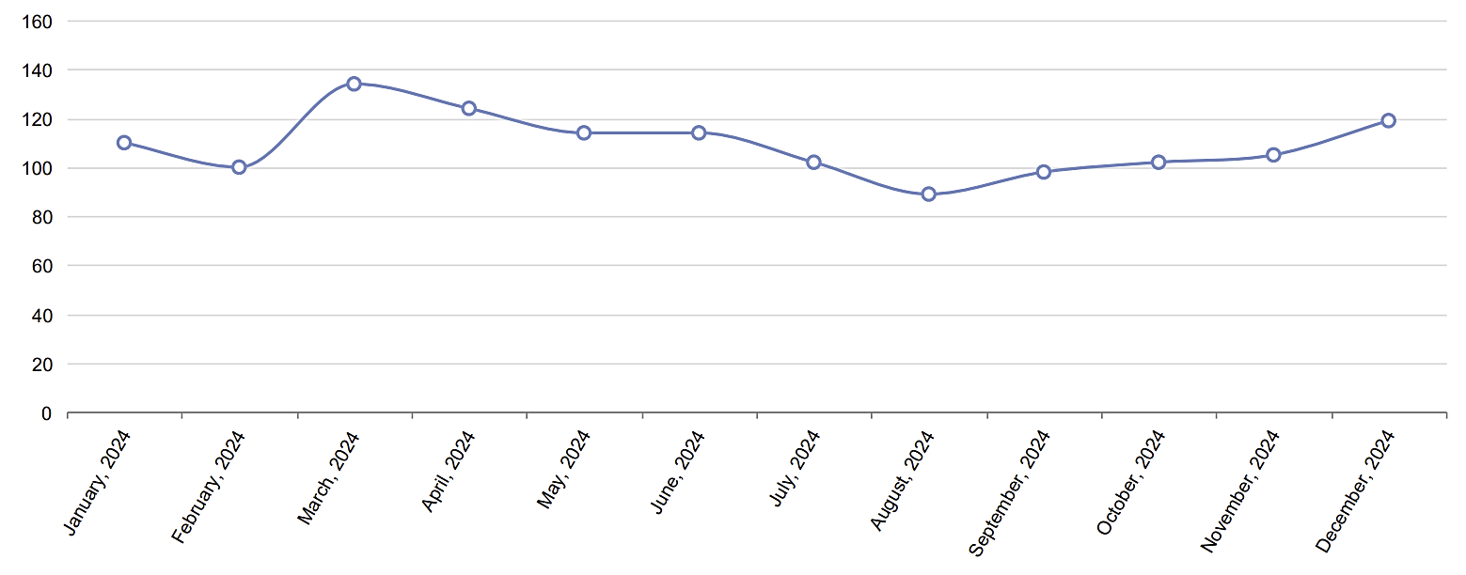

2024 Number of **Contributions**

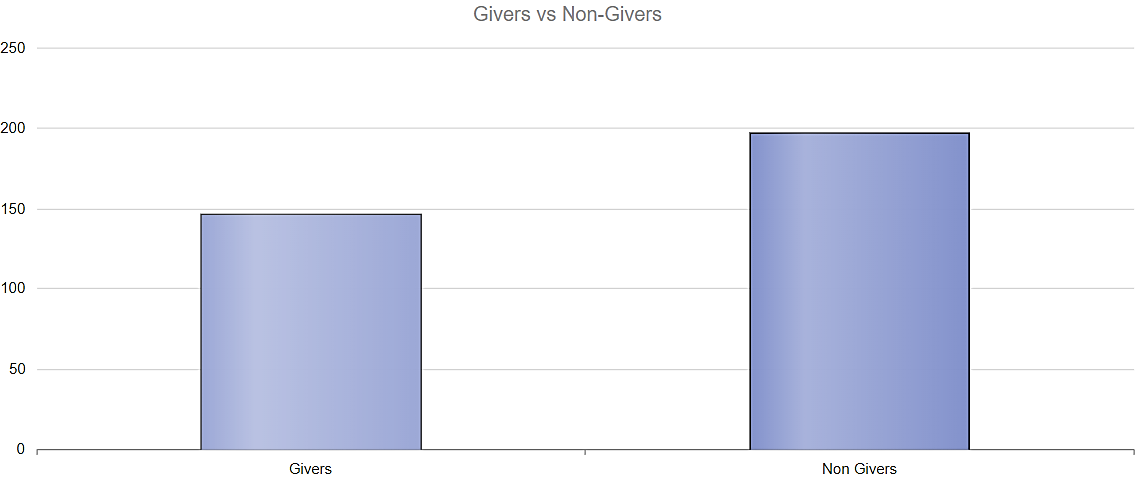

2024 Givers vs Non-givers

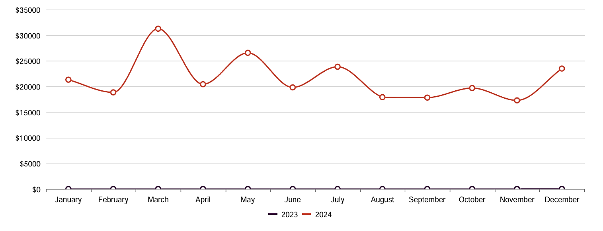

2024 **Contributions** by Month

2024 Number of **Contributors** by Month

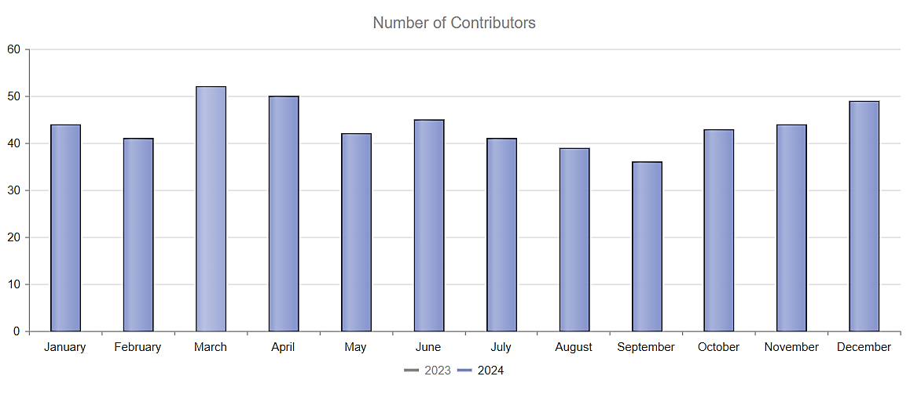

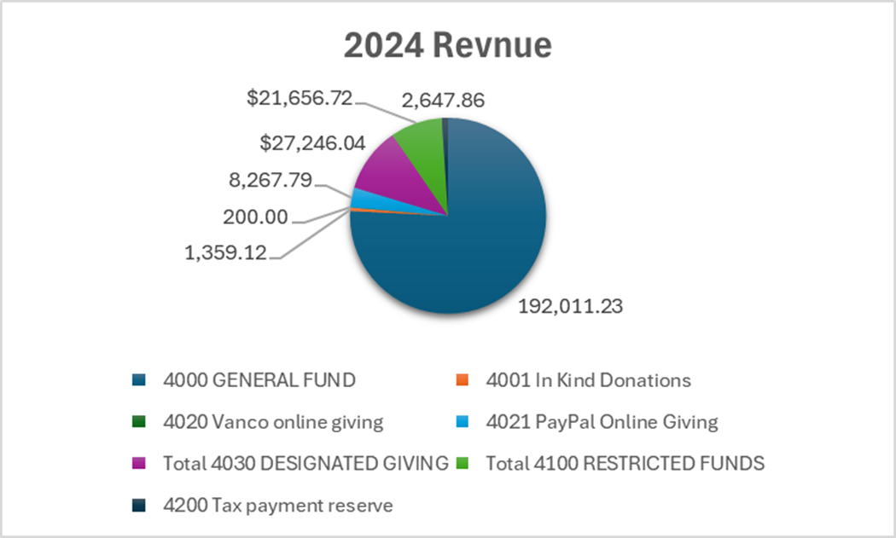

|  |  |
| --- | --- |
| **Corner House Christian Church** | |
| **Statement of Activity** | |
| **January - December 2024** | |
|  |  |
| **REVENUE** |  |
|  |  |
| 4000 GENERAL FUND | 192,011.23 |
| 4001 In Kind Donations | 1,359.12 |
| 4020 Vanco online giving | 200.00 |
| 4021 PayPal Online Giving | 8,267.79 |
| 4030 DESIGNATED GIVING |  |
| 4017 Food Pantry | 2,705.00 |
| 4032 Memorial Fund | 2,180.00 |
| 4033 Missions | 18,426.63 |
| 4035 Funeral Dinner | 18.71 |
| 4038 Benevolent Fund | 2,095.70 |
| 4039 Hall Rental | 1,820.00 |
| *Total 4030 DESIGNATED GIVING* | $ 27,246.04 |
| 4100 RESTRICTED FUNDS |  |
| 4101 Capital Improvement Contingency Fund (Building Fund) | 10,410.65 |
| 4102 Pavilion Fund (restricted) | 1,736.50 |
| 4103 Children's Discipleship Fund (restricted) | 6,093.40 |
| 4104 Mission Trips (Restricted) | 100.00 |
| 4105 Women's Ministry (Restricted) | 786.17 |
| 4106 Trumbull County Sewer Assessment (459.47/mo restricted) | 2,530.00 |
| *Total* ***4100*** *RESTRICTED FUNDS* | **$ 21,656.72** |
| 4200 Tax payment reserve | 2,647.86 |
| Total Revenue | $ 253,388.76 |
| **EXPENDITURES** |  |
| 5000 GENERAL OPERATING EXPENSES |  |
| 5002 Property Taxes | 1,995.36 |
| 5003 Property insurance | 8,654.80 |
| 5004 Memberships & Subscriptions | 1,324.34 |
| 5005 Bank fees & service charges | 53.85 |
| 5006 Trumbull County Sewer Assessment | 5,513.75 |
| **Total 5000 GENERAL OPERATING EXPENSES** | **$ 17,542.10** |
| 5010 MINISTRIES |  |
| 5011 Food and Fellowship Ministry | 1,864.31 |
| 5012 Evangelism Ministry | 1,026.13 |
| 5013 Food Pantry | 1,250.00 |
| Total 5012 Evangelism Ministry | $ 2,276.13 |
| 5014 Worship Ministry | 3,430.77 |
| 5015 Discipleship Ministry Children | 5,387.19 |
| 5016 Discipleship Ministry Adults | 1,477.21 |
| Total 5010 MINISTRIES | $ 14,435.61 |
| 5030 CHARITABLE CONTRIBUTIONS |  |
| 5033 Missions Allocation from General Fund | 16,996.62 |
| 5035 Deacon's Benevolent Fund | 1,567.71 |
| Total 5030 CHARITABLE CONTRIBUTIONS | $ 18,564.33 |
| 5070 UTILITIES |  |
| 5071 Electric | 4,925.97 |
| 5072 Telephone | 4,038.00 |
| 5073 Natural Gas | 2,054.16 |
| 5074 Trash Disposal | 2,500.48 |
| 5075 Water & Sewer | 2,766.84 |
| 5076 Internet | 2,054.64 |
| Total 5070 UTILITIES | $ 18,340.09 |
| 5090 ALL BUILDINGS/GROUNDS REPAIR/MAINTENANCE |  |
| 5091 Church Building Repair/Maintenance | 16,855.71 |
| 5092 Pest Control | 1,187.00 |
| 5093 Parsonage Repair/Maintenance | 429.39 |
| 5094 Pavilion Expense | 89.97 |
| 5095 Seasonal Property Maintenance | 3,477.19 |
| 5096 Elevator Compliance/repair | 714.25 |
| 5097 Cleaning/janitorial supplies | 1,055.63 |
| Total 5090 ALL BUILDINGS/GROUNDS REPAIR/MAINTENANCE | $ 23,809.14 |
| 5100 OFFICE EXPENSES |  |
| 5101 Office supplies | 485.33 |
| 5103 Equipment lease & maintenance | 3,352.29 |
| 5104 Shipping & postage | 262.25 |
| Total 5100 OFFICE EXPENSES | $ 4,099.87 |
| 5120 INFORMATION TECHNOLOGY |  |
| 5121 Church Office Computer Software/Apps | 1,273.12 |
| 5122 Church Office Computer Hardware | 2,391.18 |
| 5123 Worship Ministry Software/Apps/Licensing | 1,521.51 |
| 5124 Worship Ministry Computer Hardware | 2,327.13 |
| 5125 Social Media | 379.30 |
| 5126 Church Webpage | 369.10 |
| 5127 Accounting & Church Management Software | 2,690.75 |
| Total 5120 INFORMATION TECHNOLOGY | $ 10,952.09 |
| 5300 PAYROLL EXPENSES |  |
| 5301 Salaries and Wages | 73,045.57 |
| 5303 Reimbursements | 3,704.43 |
| 5304 Workers' compensation insurance | 171.00 |
| 5305 Christian Churches Pension Plan | 4,062.50 |
| 5306 New York Life Retirement Fund | 1,306.50 |
| 5308 Federal withholding taxes | 2,039.49 |
| 5311 Cell Phone charge | -2,500.00 |
| 5312 Late filing fees for payroll taxes (2013 & 2015) | 15,221.82 |
| Total 5300 PAYROLL EXPENSES | $ 97,051.31 |
| Total Expenditures | $ 204,794.54 |
| Net Operating Revenue | $ 48,594.22 |
| **Other Revenue** |  |
| 4010 MISCELLANEOUS REVENUES |  |
| 4012 Grave Purchase/Opening | 1,800.00 |
| 4013 Misc designated giving | 536.38 |
| 4014 Holiday Flowers | 228.00 |
| 4015 Refund | 200.00 |
| 4016 Interest Received | 680.39 |
| Total 4010 MISCELLANEOUS REVENUE | $ 3,444.77 |
| Total Other Revenue | $ 3,444.77 |
| **Other Expenditures** |  |
| 5040 MISCELLANEIOUS EXPENSES |  |
| 5043 Grave Opening | 1,000.00 |
| 5045 Mercy Health Stepping Out payment | 60.00 |
| 5046 Returned checks, NSF, stop payment | 200.00 |
| 5047 Uncategorized supplies/purchases | 336.88 |
| Total 5040 MISCELLANEIOUS EXPENSES | $ 1,596.88 |
| Total Other Expenditures | $ 1,783.16 |
| Net Other Revenue | $ 1,661.61 |
| Net Revenue | **$ 50,255.83** |

|  |  |  |  |  |
| --- | --- | --- | --- | --- |
|  | |  |  |  |
| **Corner House Christian Church 2025 Proposed Budget** | | |  |  |
|  | |  |  |  |
|  | | **2025**  **proposed** |  | **2024** |
|  | |  | **actual** |
|  | |  |  |  |
| **5000 General Operating Expenses** | | **20,000.00** |  | **17,542.10** |
|  | |  |  |  |
| **5011 Food and Fellowship Ministry** | | **2,000.00** |  | **1,864.31** |
|  | |  |  |  |
| **5012 Evangelism Ministry** | | **2,000.00** |  | **1,026.13** |
|  | |  |  |  |
| **5013 Discipleship Ministry Adults** | | **2,000.00** |  | **1,477.21** |
|  | |  |  |  |
| **5014 Worship Ministry** | | **7,300.00** |  | **3,430.77** |
|  | |  |  |  |
| **5015 Discipleship Ministry Children** | | **6,000.00** |  | **5,387.19** |
|  | |  |  |  |
| **5070 Utilities** | | **25,000.00** |  | **18,340.09** |
|  | |  |  |  |
| **5090 All Buildings/Grounds Repair/Maintenance** | | **17,000.00** |  | **23,808.14** |
|  | |  |  |  |
| **5100 Office Expenses** | | **5,200.00** |  | **4,099.87** |
|  | |  |  |  |
| **5120 Information Technology** | | **10,000.00** |  | **10,952.09** |
|  | |  |  |  |
| **5300 Payroll Expenses** | | **105,000.00** |  | **97,051.31** |
|  |  | |  |  |
| **Total** | | **201,500.00** |  | **184,979.21** |